**Kahoot questions**  
  
1 ___ is one in which all the Business relationships with customers, suppliers, & employees are digitally enabled  
Enterprise firm  
Digital firm

Profitable firm

Process-oriented firm

2 ___ are accomplished through digital networks spanning the entire organization or linking multiple organizations.

Core business functions

Core business applications

Core business processes

None of the above

3 The core components of information system do not include

People

Profit making

Hardware and software

Policies and Procedures  
  
include: Computer hardware, Computer software, Telecommunications, Databases and data warehouses, Human resources and procedures

4 ___ refer to the set of logically related tasks and behaviors that organizations develop to produce business results

Business processes

Business applications

Business functions

Business integration

5 ___ describes how a company produces, delivers, and sells a product or service to create wealth.  
An E-commerce model

A profit model

An E-business model

A business model

6 Strategic business objectives of information systems do not include

Operational Excellence

Improved Decision Making

Customer and Supplier Intimacy

None of the choices

7 Set of interrelated components that collect, process, store, and distribute information to support decision-making is

Information Technology

Innovation Technology

Information System

Innovation system

8 Who makes long-range strategic decisions about products & services as well as ensures financial performance of the firm

Middle-level management

Operational level management

Senior level management

Low level management

9 Who carries out the programs and plans of senior management?

Middle-level management

Operational level management

Senior level management

None of the choices

10 Who is responsible for monitoring the daily activities of the business?

Middle-level management

Operational level management

Senior level management

All of the choices

11 ___ such as engineers, scientists, or architects, design products or services and create new knowledge for the firm

Data workers

Knowledge workers

Service workers

12 Each organization has a unique ___ values, and ways of doing things, that has been accepted by most of its members.

Culture

Methodology

Business process

Assumptions

13 Internal corporate networks based on Internet technology are called

Intranets

Internet

Extranets

All of the choices

14 Private intranets extended to authorized users outside the organization are called

Intranets

Internet

Extranets

All of the choices

15 The __ provides the foundation, or platform, on which the firm can build its specific information systems.

IT networks

IT capabilities

IT Infrastructure

IT components

16 The __ to information systems emphasizes mathematically based models to study information systems

Behavioural approach

Societal approach

Technical approach

All of the choices

17 CBIS stands for

Computer-Based innovation systems

Computer-Based information systems

Computer-Based integrated systems

Computer-Business information systems

18 Global Organization of Oriented Group Language of Earth relates to

GPS

Apple

Google

Microsoft

19 CEO and co-founder of Kaspi is  
Mikhail Jordon

Mikhail Lomtadze

None of the choices

20 ___ is a suite of integrated software modules and a common central database

Supply chain management (SCM)

Supplier relationship management (SRM)

Enterprise resource planning (ERP)

Customer relationship management(CRM)

21 ___ consists of the organizations and processes for distributing and delivering products to the final customers.

The downstream portion

The upstream portion

The horizontal portion

None of the choices

22 Information about demand for a product gets distorted as it passes from one entity to the next across the supply chain

Bluewipe effect

Bluewhip affect

Bullwipe affect

Bullwhip effect

23 Procuring raw materials, transforming into finished products, & distributing the finished products to customers is

Value chain

Supply chain

Supply chart

Value supply

24 In a ___, production master schedules are based on forecasts or best guesses of demand for products

A Pull-based model

Push-based model

PushPull-based model

None of the choices

25 __ is a set of integrated software modules that enables data to be shared by many different business processes

Enterprise hierarchy

Enterprise systems

Enterprise network

None of the above

26 Personnel administration, time accounting, payroll, personnel planning and development, benefits accounting refers to

d accounting processes

g and production processes

Human resources processes

Sales and marketing processes

27 Order processing, quotations, contracts, product configuration, pricing, billing, crediting checking refers to

Sales and marketing processes

Human resources processes

Financial and accounting processes

Manufacturing and production processes

28 ___ provide value by increasing operational efficiency and by providing firmwide information to make better decisions.

Enterprise systems

29 ___ includes the company's suppliers, the suppliers' suppliers, and the processes for managing relationships with them.

The downstream portion

The upstream portion

The horizontal portion

None of the choices

30 ___ deals with employee issues, such as setting objectives, performance management, compensation and employee training

ERM

PRM

ERP

CRM

31 Components arrive at the moment they were needed and finished goods would be shipped as they left the assembly line.

Just-On-Time

Just-In-Time

Just-In-Transaction

Just-On-Transaction

32 ___ models its existing processes, generate demand forecasts, and develop optimal sourcing and manufacturing plans

Supply chain planning systems

33 ___ analyze customer data generated by operational CM applications to provide information for improving business

Operational CRM

Analytical CRM

Collaborative CRM

All of the choices

34 ___ in CRM provide information & tools to increase the efficiency of call centers, help desks, & customer support staff.

Customer support models

Customer satisfication modules

Customer service modules

Customer care modules

35 Which determines how much product a business needs to make to satisfy all of its customers' wants?

Supply planning

Customer planning

Demand Planning

Market planning

36 ___ is a demand-driven or build-to-order model, actual customer orders or purchases trigger events in the supply chain

Pull-based model

37 ____ is a method of interaction with the customer, such as telephone, e-mail, customer service desk, conventional mail

A touch point

A remote point

A point of contact

38 ___ uses many of same data, tools, & systems as CRM to enhance collaboration between a company and its selling partners

ERM

PRM

ERP

CRM

39 ___ measures the number of customers who stop using or purchasing products or services from a company.

Churn risk

Churn rate

Churn items

Churn products

40 In ________, the price of a product varies depending on the demand characteristics of the customer or the supply situation of the seller  
Strategic pricing

Volatile pricing

Fluctuating pricing

Dynamic pricing

41 The difference between the revenue produced by a specific customer, the expenses incurred in acquiring and servicing that customer, and the expected life of the relationship between the customer and the company is

Customer lifetime value

Customer lifelong value

Customer all-time value

Customer relationship value

42 A firms ___ describes how the firm will earn revenue, generate profits, and produce a superior return on investment

Profit model

Business model

Revenue model

Sales model

43 ____ are established as peer-to-peer betting markets where participants make bets on specific outcomes of, say, quarterly sales of a new product, designs for new products, or political elections.

Subscription markets

Prediction markets

Prescription markets

Preventive markets

44 __ modules in CRM help sales staff increase their productivity by focusing sales efforts on the most profitable customers, those who are good candidates for sales and services.

Customer Relationship Management

Sales Force Automation

Profit Optimization Modules

Service Candidate Enhancement

45 From a consumer point of view, ubiquity reduces ________—the costs of participating in a market

Transaction costs

Market cost

Supply chain costs

Ownership costs

46 Refers to the ability of consumers to discover the actual costs merchants pay for products; refers to the ease with which consumers can find out the variety of prices in a market

Price Visibility

Cost Clarity

Cost transparency

Market Rate Discoverability

47 ____ refers to all forms of human expression that can be put into a tangible medium such as text, CDs, or DVDs, or stored on any digital (or other) media, including the Web.

Knowledge Holdings

Intellectual property

Creative Assets

Mind Creations

48 ____ refers to tracking the clickstreams (history of clicking) of individuals on thousands of Web sites for the purpose of understanding their interests and intentions, and exposing them to advertisements that are uniquely suited to them.  
Customized marketing

Personalised marketing

Target marketing

Behavioral targeting

49 _ refers to the manner in which work is organized, coordinated, and focused to produce a valuable product or service.  
Business functions

Business tasks

Business processes

Business services

50 Assembling the product, checking for quality, and Producing bills of materials processes belong to this functional area

Finance and accounting

Sales and marketing

Human resources

Manufacturing and production

51 At the ___, tasks, resources, and goals are predefined and highly structured.

Top level / Strategic level

Low level / Operational level

Middle level

All of the above

52 ___ provide middle managers with reports on the organization's current performance.

Management Information Systems

Executive information Systems

Decision Support Systems

Middle Level System

53 ___ focus on problems that are rapidly changing, for which the arriving at a solution may not be fully predefined

Operations Support systems

Executive Information systems

Decision Support systems

Middle Level System

54 ___ address non-routine decisions requiring judgment, and evaluation, as there is no agreed-on procedure for solution

Management Information Systems

Executive Support Systems

Operations Support systems

All of the above

55 __ displays on a single screen graphs and charts of key performance indicators for managing a company

Digital boards

Analog dashboards

Digital dashboards

Digital displays

56 ___ is the part of ___ that deals with the buying and selling of goods and services over the internet.

E-business, E-commerce

E-commerce; E-business

E-commerce; E-Tailing

E-Tailing; E-business

57 ___ refers to the application of the internet and networking technologies to digitally enable public sector agencies

E-governance

Digitally enablad firm

Enterprise Resource Planning

Hybrid networks

58 __ is the use of social networking platforms, & corporate social tools-to engage employees, customers, and suppliers.

Social network

Social business

Social media

Social connectivity

59 Publish and rapidly access knowledge; discuss opinions and experiences - closely relates with

Blogs and wikis

shared workspaces

Social networks

Social marketing

60 Discuss topics in open forums; share expertise - closely relates with

Communities

Crowdsourcing

Social commerce

Social networks

61 ___ are online filo-sharing services that allow users to upload files to secure online storage sites

Cloudlockers

Onlinelockers

Safelockers

Cyberlockers

62 ___ is a browser based collaboration and document management platform, combined with a powerful search engine

Google Drive

Drop box

MS SharePoint

Digital Ocean

63 CIO refers to

Chief investigation Officer

Chief intelligence Officers

Chief information Officer

Chief information Offer

64 ___ Includes the strategy and policies for using information technology within an organization Terms and conditions

Terms and conditions

IT governance

Procedures and policies

Tech protocols

65 Deciding entry or exit from markets, approval of capital budgets, decide long term goals -refers to

Structured decisions

Multidimensional decisions

Semistructured decisions

None of the above

66 Which of the following is not part of stages in decision making?

Intelligence

Modeling

Implementation

Design

67 Managerial roles are expectations of the activities that managers should perform. It does not include

Interpersonal role

Informational Roles

Profit guarantee role

Decisional Roles

68 __ Is the structure of data and relationships among the entities and attributes consistent? - closely relates with

Accuracy

Consistency

Integrity

Completeness

69 The Business Intelligence Environment includes

Data from the business environment

Business analytics toolset

Business Intelligence infrastructure

Covering All the choices

70 These allow users to create their own reports based on queries and searches

Dashboards/scorecards

Ad hoc query/search/report creation

Parameterized reports

Forecasts, scenarios, models

71 The first search engine on the internet is

Yahoo

Archie

Bing

Google

72 The first computer virus was known as

Rabbit

SCA Virus

Elk Cloner

Creeper Program

73 Which of the following programming language is used to create programs like applets?

COBOL

Java

C Language

BASIC

74 Computer Hard Disk was first introduced in 1956 by

A Dell

Microsoft

Apple

IBM

75 In computer world, Trojan refer to

A Virus

Worm

Malware

Spyware

76 In which year ‘@' sign was first chosen for its use in e-mail address

1976

1977

1980

1972

77 What is the extension of PDF?

Portable digital format

Portable document format

Portable document files

Portable digital files

78 A folder in windows computer can’t be made with the name

Can

Mak

Con

Make

79 ___ is a specific measure of quality, representing 3.4 defects per million opportunities.

Efficiency

Six sigma

Accuracy

Productivity

80 __ refer to the manner in which work is organized, coordinated, and focused to produce a valuable product or service.

Business processes

Business tasks

Business services

Business functions

81 ___ shows how the system will fulfil this objective and __ describes what a system should do to meet information requirements

Systems analysis; Systems design

Systems design; System integration

System analysis; System integration

Systems design; Systems analysis

82 ___ is used to describe the process of creating workable systems in a very short period of time.

Joint application development

Agile development

Rapid application development

None of the choices

83 The Configuration, management, and development of systems that tend to follow global strategy, the “Systems development and operation occur totally at domestic home base” is referred to which type of systems configuration?

Duplicated

Decentralized

Centralized

Networked

84 Discuss topics in open forums; share expertise - closely relates with

Crowdsourcing

Communities

Social networks

Social commerce

85 _ address non-routine decisions requiring judgment, evaluation, and insight because there is no agreed-on procedure for arriving at a solution.

All of the choices

Executive Support Systems

Operations support systems

Management Information Systems

86 In a ___, both the old system and its potential replacement are run together for a time until everyone is assured that the new one functions correctly.

Pilot study strategy

Phased approach strategy

Direct cutover strategy

Parallel strategy

87 Changes in hardware, software, documentation, or procedures to a production system to correct errors, meet new requirements, or improve processing efficiency are termed

Adaption

Transformation

Translation

Maintenance

88 ____ consists of building an experimental system rapidly and inexpensively for end users to evaluate. By interacting with this, users can get a better idea of their information requirements.

Sampling

Designing

Replicating

Prototyping

89 The ____ strategy replaces the old system entirely with the new system on an appointed day

Parallel strategy

Direct cutover strategy

Phased approach strategy

Pilot study strategy

90 __ tries to determine whether discrete modules will function together as planned and whether discrepancies exist between the way the system actually works and the way it was conceived.

System testing

Integration testing

Acceptance testing

Case testing

91 ___ refers to the application of the Internet and networking technologies to digitally enable public sector agencies

Digitally enabled firm

Enterprise Resource Planning

E-governance

Hybrid networks

92 Give the right order of Steps in Prototyping

I: Use the prototype;

G: Identify the user’s basic requirements;

A: Revise and enhance the prototype;

Z: Develop an initial prototype

A, I, Z, G

G, Z, I, A

G, A, Z, I

G, I, A Z

93 The Configuration, management, and development of systems that tend to follow global strategy, the “Development occurs at home base but operations are handed over to autonomous units in foreign locations” is referred to which type of systems configuration?

Centralized

Networked

Decentralized

Duplicated

94 Assembling the product, checking for quality, and Producing bills of materials processes belongs to this functional area

Human resources

Finance and accounting

Manufacturing and production

Sales and marketing

95 ____ reorganizes workflows, combining steps to cut waste and eliminate repetitive, paper-intensive tasks.

Business process change

Business process improvements

Business process refinement

Business process redesign

96 ___ offers a logical graphic model of information flow, partitioning a system into modules that show manageable levels of detail.

Data flow diagram

Flowcharts

Logical diagram

Graphical diagram

97 __ brings end users and information systems specialists together in an interactive session to discuss the system’s design.

Agile development

Joint application development

Rapid application development

End used development

98 ________ features allow a software package to be modified to meet an organization’s unique requirements without destroying the integrity of the packaged software.

(Баллов: 1)

Collaboration

Integration

Customization

Specification

99 These allow users to create their own reports based on queries and searches.

(Баллов: 1)

Ad hoc query/search/report creation

Forecasts, scenarios, models

Dashboards/scorecards

Parameterized reports

100 Publish and rapidly access knowledge; discuss opinions and experiences – closely relates with

Social marketing

Shared workspaces

Social networks

Blogs and wikis

101 ________ is the process of changing from the old system to the new system.

Translation

Adaption

Conversion

Transformation

102 ____ focus on problems that are unique and rapidly changing, for which the procedure for arriving at a solution may not be fully predefined in advance

Operations support systems

Middle Level System

Decision Support Systems

Executive Information Systems

103_________ enables Web sites to automatically change layouts according to the visitor’s screen resolution, whether on a desktop, tablet, or smartphone.

Dynamic Web design

Flexible Web design

Reactive Web design

Responsive Web design

104 Which of the following steps the Business process management does not go through?

Analyse existing processes

Database design and development

Implement the new process

Design the new process

105 The _________ introduces the new system in stages, either by functions or by organizational units.

Direct cutover strategy

Phased approach strategy

Pilot study strategy

Parallel strategy

106 ________ provides software tools to automate the methodologies we have just described to reduce the amount of repetitive work the developer needs to do.

SCM

ERP

CRM

CASE

107 The Configuration, management, and development of systems that tend to follow global strategy, the “Development and operations occur in coordinated fashion across all units” is referred to which type of systems configuration?

Decentralized

Centralized

Duplicated

Networked

**1 attestation**

1.What’s new in Management Information Systems(MIS)?

ANS**: *Cloud computing, Big data, mobile digital platform***

2.________ refer to the set of logically related tasks and behaviors that organizations develop over time to produce specific business results and the unique manner in which these activities are organized and coordinated.

ANS***: Business processes***

3. A _______ is one in which nearly all of the organization’s significant business relationships with customers, suppliers, and employees are digitally enabled and mediated

ANS: ***Digital firm***

***4.*** In _________, there is a growing interdependence between a firm’s information systems and its business capabilities.

ANS: ***contemporary systems***

***5.*** What describes how company produces, delivers and sells a product or service to create wealth?

ANS: ***A business model***

***6.***What is strategic business objectives of information systems?

ANS: ***Operational Excellence, New products services and business models, Customer and supplier intimacy, Competitive advantage, Improved decision making, Survival***

***7.*** _______ consists of all the hardware and software that a firm needs to use in order to achieve its business objectives

ANS: ***Information technology***

8. ____, in contrast, are streams of raw facts representing events occurring in organizations or the physical environment before they have been organized and arranged into a form that people can understand and use.

ANS: ***Data***

***9.*** What three activities in an information system produce the information that organizations need to make decisions, control operations, analyze problems, and create new products or services?

ANS: ***Input, Processing, Output***

***10.*** The field of______ tries to achieve this broader information systems literacy.

ANS: ***Management Information Systems***

***11.*** , What encompasses an understanding of the management and organizational dimensions of systems as well as the technical dimensions of systems ?

ANS: ***information systems literacy***

***12.*** What makes long-range strategic decisions about products and services as well as ensures financial performance of the firm?

ANS: ***Senior Management***

***13.***______ carries out the programs and plans of senior management?

ANS: ***Middle Management***

***14. ______*** is responsible for monitoring the daily activities of the business?

ANS: ***Operational Management***

***15. ______*** such as engineers, scientists, or architects, design products or services and create new knowledge for the firm?

ANS: ***Knowledge workers***

***16. ____*** such as secretaries or clerks, assist with scheduling and communications at all levels of the firm?

ANS: ***Data workers***

***17.*** Who actually produce the product and deliver the service?

ANS: ***Production or service workers***

***18.***  The major______, or specialized tasks performed by business organizations, consist of sales and marketing, manufacturing and production, finance and accounting, and human resources

ANS: ***Business functions***

***19.*** What are major business functions?

ANS: ***Sales and marketing, manufacturing and production, finance and accounting, Human resources***

***20.*** What is the physical equipment used for input, processing, and output activities in an information system?

ANS: ***Computer hardware***

***21.*** _____ consists of the detailed, preprogrammed instructions that control and coordinate the computer hardware components in an information system?

ANS***: Computer software***

***22.*** What consists of the software governing the organization of data on physical storage media?

ANS: ***Data management technology***

***23.*** ____ consisting of both physical devices and software, links the various pieces of hardware and transfers data from one physical location to another

ANS: ***Networking and telecommunications technology***

***24.*** What links two or more computers to share data or resources?

ANS: ***A network***

***25.*** Internal corporate networks based on Internet technology are called ____?

ANS: ***Intranets***

***26.*** Private intranets extended to authorized users outside the organization are called ____?

ANS: ***Extranets***

***27.*** What provides the foundation, or platform, on which the firm can build its specific information systems?

ANS: ***The IT Infrastructure***

***28.*** What are those assets required to derive value from a primary investment?

ANS: ***Complementary assets***

***29.*** ____ is a stable, formal social structure that takes resources from the environment and processes them to produce outputs.

ANS: ***An Organization***

***30.*** In some cases, _____ are substitute products that perform as well as or better (often much better) than anything currently produced.

ANS: ***Disruptive technologies***

***31.*** According to _____, firms and individuals seek to economize on transaction costs, much as they do on production costs.

ANS: ***transaction cost theory***

32. According to ____, the firm is viewed as a “nexus of contracts” among self-interested individuals rather than as a unified, profit-maximizing entity.

ANS: ***Agency theory***

***33.*** The most widely used model for understanding competitive advantage is?

ANS: ***Michael Porter’s competitive forces model***

***34.*** What are other forces in Michael Porter’s competitive force model other than traditional direct competitors?

ANS: ***New market entrants, Substitute products, Bargaining power of Customers and Suppliers(or just customers and suppliers)***

***35.*** What are IS strategies for dealing with competitive forces?

ANS: ***Low-cost leadership, product differentiation, focus on market niche, customer and supplier intimacy.***

***36.*** This ability to offer individually tailored products or services using the same production resources as mass production is called _______?

ANS: ***Mass customization***

***37.*** Strong linkages to customers and suppliers increase ____?

ANS: ***Switching costs.***

***38.*** What highlights specific activities in the business where competitive strategies can best be applied?

ANS: ***The Value chain model***

***39.*** _____ are most directly related to the production and distribution of the firm’s products and services?

ANS: ***Primary activities***

***40. ____*** make the delivery of the primary activities possible and consist of organization infrastructure?

ANS: ***Support activities***

***41.*** What involves comparing the efficiency and effectiveness of your business processes against strict standard?

ANS: ***Benchmarking***

***42.*** ______ is a collection of independent firms that use information technology to coordinate their value chains to produce a product or service for a market collectively?

***ANS: A Value web.***

***43.*** _____ is an activity for which a firm is a world-class leader?

ANS: ***A*** ***core competency***

***44.*** What uses networks to link people, assets, and ideas, enabling it to ally with other companies to create and distribute products and services without being limited by traditional organizational boundaries or physical locations?

ANS: ***A virtual company***

***45.*** A movement between levels of sociotechnical systems?

ANS: ***Strategic transitions***

***46.*** _____ is built around thousands of predefined business processes that reflect best practices.

ANS: ***Enterprise software***

***47.*** A firm’s ____ is a network of organizations and business processes for procuring raw materials

ANS: ***supply chain***

***48.*** What portion of the supply chain includes the company’s suppliers, the suppliers’ suppliers, and the processes for managing relationships with them?

ANS: ***The upstream portion***

***49.*** The ____ consists of the organizations and processes for distributing and delivering products to the final customers.

ANS: ***downstream portion***

***50.*** Information about the demand for a product gets distorted as it passes from one entity to the next across the supply chain.

ANS: ***Bullwhip effect***

***51.*** Which systems enable the firm to model its existing supply chain, generate demand forecasts for products, and develop optimal sourcing and manufacturing plans?

ANS: ***Supply chain planning***

***52.*** What determines how much product a business needs to make to satisfy all of its customers’ demand?

ANS: ***Demand planning***

***53.*** Which systems manage the flow of products through distribution centers and warehouses to ensure that products are delivered to the right locations in the most efficient manner?

ANS: ***Supply chain execution systems***

***54.*** In Which model production master schedules are based on forecasts or best guesses of demand for products?

ANS: ***In a push-based model***

***55.*** In Which model actual customer orders or purchases trigger events in the supply chain?

ANS***: pull-based model or demand-driven***

***56. ­­­­____*** is a method of interaction with the customer?

ANS: ***A touch point (also known as a contact point)***

***57.*** What is the marketing of complementary products to customers?

ANS: ***Cross-selling***

***58. _____*** includes customer- facing applications, such as tools for sales force automation, call center and customer service support, and marketing automation?  
ANS: ***Operational CRM***

***59.______*** includes applications that analyze customer data generated by operational CRM applications?

ANS: ***Analytical CRM***

***60.*** _____ is based on the relationship between the revenue produced by a specific customer, the expenses incurred in acquiring and servicing that customer, and the expected life of the relationship between the customer and the company?  
ANS: ***Customer lifetime value (CLTV***)

61. What measures the number of customers who stop using or purchasing products or services from a company?

ANS***: The churn rate.***

***62. _____*** tools enable a business to connect customer conversations and relationships from social networking sites to CRM processes?

ANS: ***Social CRM***

***63. ______*** refers to the use of the Internet and the Web to transact business?  
ANS: ***E-commerce***

***64.*** A marketplace extended beyond traditional boundaries and removed from a temporal and geographic location?

ANS: ***Marketspace***

***65.*** costs of participating in a market?

ANS: ***Transaction costs***

***66.***_____- the cost merchants must pay simply to bring their goods to market?

ANS: ***market entry costs***

***67.*** the effort required to find suitable products?

ANS: ***Search costs***

***68.*** Information _____ refers to the complexity and content of a message?

ANS: ***Richness***

***69.*** the total amount and quality of information available to all market participants?

ANS: ***Information density***

***70.*** the ease with which consumers can find out the variety of prices in a market?

ANS: ***Price transparency***

***71.*** the ability of consumers to discover the actual costs merchants pay for products?

ANS: ***Cost transparency***

***72.*** selling the same goods, or nearly the same goods, to different targeted groups at different prices?

ANS: ***Price discrimination***

***73. C***hanging the delivered product or service based on a user’s preferences or prior behavior?

ANS: ***Customization***

***74.*** Adjusting the message to a person’s clickstream behavior, name, interests, and past purchases?  
ANS: ***Personalization***

***75.*** When one party in a transaction has more information that is important for the transaction than the other party?

ANS: ***Information asymmetry***

***76.*** merchants’ costs of changing prices?  
ANS: ***Menu costs***

***77.*** Whenthe price of a product varies depending on the demand characteristics of the customer or the supply situation of the seller.  
ANS: ***Dynamic pricing***

***78.*** The removal of organizations or business process layers responsible for intermediary steps in a value chain is called?

ANS: ***Disintermediation***

***79.*** Goods that can be delivered over a digital network?

ANS: ***Digital goods***

***80.*** sales of goods and services among businesses?

ANS: ***Business-to-business***

***81.*** retailing products and services to individual shoppers?

ANS***: Business-to-consumer***

***82.*** consumers selling directly to consumers?

ANS:***Consumer-to-consumer***

***83.*** The use of handheld wireless devices for purchasing goods and services from any location is termed?

ANS: ***Mobile commerce***

***84.*** Online retail stores are called?

ANS: ***e-tailers***

***85.*** all forms of human expression that can be put into a tangible medium such as text, CDs, or DVDs?

ANS: ***Intellectual Property***

***86.*** ______ build a digital environment in which buyers and sellers can meet, display products, search for products, and establish prices?

ANS: ***Market creators***

***87.***  sites that create a digital online environment where people with similar interests can transact (buy and sell goods?

ANS: ***Community providers***

***88.*** A firm’s ______ describes how the firm will earn revenue, generate profits, and produce a superior return on investment?  
ANS: ***revenue model***

***89.*** Web site generates revenue by attracting a large audience of visitors who can then be exposed to advertisements?

ANS: ***Advertising revenue model***

***90.*** companies derive revenue by selling goods, information, or services to customers?

ANS: ***Sales revenue model***

***91.*** Web site offering content or services charges a subscription fee for access to some or all of its offerings on an ongoing basis?

ANS: ***Subscription revenue model***

***92.*** firms offer basic services or content for free, while charging a premium for advanced or special features?

ANS: ***free premium model***

***93.*** a company receives a fee for enabling or executing a transaction?

ANS: ***Transaction fee revenue model***

***94.*** Web sites send visitors to other Web sites in return for a referral fee or percentage of the revenue from any resulting sales?

ANS: ***Affiliate revenue model***

***95.*** large numbers of people can make better decisions about a wide range of topics or products than a single person or even a small committee of experts?  
ANS: ***wisdom of crowds***

***96.*** Peer-to-peer betting markets where participants make bets on specific outcomes of, say, quarterly sales of a new product?  
ANS: ***Prediction markets***

***97. t***racking the clickstreams (history of clicking behavior) of individuals on thousands of Web sites?

***ANS: Behavioral targeting***

***98.*** a large firm using a secure Web site to link to its suppliers and other key business partners?

***ANS: Private industrial networks***

***99.*** digital marketplace based on Internet technology for many different buyers and sellers?

***ANS: Net Marketplace***

***100.*** goods used in a production process?

***ANS: Direct Goods***

***101.*** goods not directly involved in the production process?

***ANS: Indirect Goods***

***102.*** include geosocial services, geoadvertising, and geoinformation services?

***ANS: Location Based services***

***103.*** your firm purchases or leases a Web server (and has total control over its operation)?

***ANS: co-location agreement***

**2 attestation**

**1 Business processes**-  
1) refer to the manner in which work is organized, coordinated, and focused to produce a valuable product or service.  
2) are the collection of activities required to produce a product or service.  
3) also refer to the unique ways in which organizations coordinate work, information, and knowledge, and the ways in which management chooses to coordinate work.

**2 Manufacturing and production** - Assembling the product, checking for quality, producing bills of materials.

**3 Sales and marketing** - Identifying customers, making customers aware of the product, selling the product.

**4 Finance and accounting** - Paying creditors, creating financial statements, managing cash accounts.

**5 Human resources** - Hiring employees, evaluating employees’ job performance, enrolling employees in benefits plans.

**6 Transaction processing systems (TPS)** -  
computerized system that performs and records the daily ***routine*** transactions necessary to conduct business, such as sales order entry, hotel reservations, payroll, employee record keeping, and shipping.

**7 Management information systems (MIS)** - designates a specific category of information systems serving ***middle management***.

**8** **Decision-support systems (DSS)** - focus on problems that are ***unique and rapidly*** changing, for which the procedure for arriving at a solution may not be fully predefined in advance

**9 Executive support systems (ESS)** - address ***non-routine*** decisions requiring judgment, evaluation, and insight because there is no agreed-on procedure for arriving at a solution.

**10 Business intelligence** - is a contemporary term for data and software tools for organizing, analyzing, and providing access to data to help managers and other enterprise users make more informed decisions.

**11 Digital dashboard** - displays on a single screen graphs and charts of key performance indicators for managing a company.

**12 Enterprise applications** help businesses become more flexible and productive by coordinating their business processes more closely and integrating groups of processes so they focus on efficient management of resources and customer service.

**13 Enterprise resource planning (ERP)** integrate business processes in manufacturing and production, finance and accounting, sales and marketing, and human resources into a single software system.

**14 E-government** refers to the application of the Internet and networking technologies to digitally enable government and public sector agencies’ relationships with citizens, businesses, and other arms of government.

**15 Cyberlockers** are online file-sharing services that allow users to upload files to secure online storage sites from which the files can be shared with others.

**16 Information systems department** is responsible for maintaining the hardware, software, data storage, and networks that comprise the firm’s IT infrastructure.

**17 Programmers** are highly trained technical specialists who write the software instructions for computers.

**18 Systems analysts** constitute the principal liaisons between the information systems groups and the rest of the organization.

**19 Chief information officer (CIO)** is a senior manager who oversees the use of information technology in the firm.

**20** **Chief security officer (CSO)** is in charge of information systems security for the firm and is responsible for enforcing the firm’s information security policy.

**21 Chief privacy officer (CPO)** is responsible for ensuring that the company complies with existing data privacy laws.

**22 Chief knowledge officer (CKO)** is responsible for the firm’s knowledge management program. The **CKO helps** design programs and systems to find new sources of knowledge or to make better use of existing knowledge in orga- nizational and management processes.

**23 End users** are representatives of departments outside of the information systems group for whom applications are developed.

24 **IT governance** includes the strategy and policies for using information technology within an organization.

**25 Systems development** is a structured kind of problem solved with distinct activities.

**26 Systems development** consist of systems analysis, systems design, programming, testing, conversion, and production and maintenance.

System analysis -> System design -> programming -> testing -> Conversion -> Production and maintenance!

**27 Systems analysis** is the analysis of a problem that a firm tries to solve with an information system.

**28 Systems analysis** describes what a system should do to meet information requirements, and **systems design** shows how the system will fulfill this objective.

**29** Есть 3 вида тестинга: **Unit testing, System testing, Acceptance testing.**

**30** . **Unit testing**(Programm testing) consists of testing each program separately in the system. guarantee that programs are ***error- free***, but this goal is realistically impossible.

**31 System testing** tries to determine whether discrete modules will function together as planned and whether discrepancies exist between the way the system actually works and the way it was conceived.

**32 Acceptance testing** provides the final certification that the system is ready to be used in a production setting.

**33 Test plan** includes all of the preparations for the series of tests we have just described.

**34 Conversion** is the process of changing from the old system to the new system.

**35** Есть **4 вида** conversion **strategies**: the **parallel strategy**, the **direct cutover strategy**, the **pilot study strategy**, and the **phased approach strategy.**

**36** In a **parallel strategy,** both the old system and its potential replacement are run together for a time until everyone is assured that the new one func- tions correctly.

**37** The **direct cutover strategy** replaces the old system entirely with the new system on an appointed day.

**38** The **pilot study strategy** introduces the new system to only a limited area of the organizations.

**39** The **phased approach strategy** introduces the new system in stages, either by functions or by organizational units.

**40** After the new system is installed and conversion is complete, the system is said to be in **production**.

**41** Changes in hardware, software, documentation, or procedures to a production system to correct errors, meet new requirements, or improve processing efficiency are termed **maintenance**.

**42 Data flow diagram (DFD)** offers a logical graphic model of information flow, partitioning a system into modules that show manageable levels of detail.

**43 Process specifications** describe the transformation occurring within the lowest level of the data flow diagrams.

**44 Computer-aided software engineering (CASE)**—sometimes called *computer-aided systems engineering*—provides software tools to automate the methodologies we have just described to reduce the amount of repeti- tive work the developer needs to do.

**45 Systems life cycle** is the oldest method for building information systems, is a phased approach to building a system, dividing systems development into formal stages

**46 Prototyping** consists of building an experimental system rapidly and inexpen- sively for end users to evaluate.

**47 Prototype** is a working version of an information system or part of the system, but it is meant to be only a preliminary model.

**48 Steps in prototyping (важно очень)**

*Step 1: Identify the user’s basic requirements*. The systems designer (usually an information systems specialist) works with the user only long enough to capture the user’s basic information needs.

*Step 2: Develop an initial prototype*. The systems designer creates a working prototype quickly, using tools for rapidly generating software.

*Step 3: Use the prototype*. The user is encouraged to work with the system to determine how well the prototype meets his or her needs and to make suggestions for improving the prototype.

*Step 4: Revise and enhance the prototype*. The system builder notes all changes the user requests and refines the prototype accordingly. After the prototype has been revised, the cycle returns to Step 3. Steps 3 and 4 are repeated until the user is satisfied.

I: Use the prototype;

G: Identify the user’s basic requirements;

A: Revise and enhance the prototype;

Z: Develop an initial prototype

ANS: G, Z, I, A

**49 Fourth-generation languages** are software tools that enable end users to create reports or develop software applications with minimal or no technical assistance.

**50 Query languages** are software tools that provide immediate online answers to requests for information that are not predefined.

**51 Customization** features allow a software package to be modified to meet an organization’s unique requirements without destroying the integrity of the packaged software.

**52 Request for Proposal (RFP)** is a detailed list of questions submitted to packaged-software vendors.

**53** The term **rapid application development (RAD)** is used to describe this process of creating workable systems in a very short period of time.

**54** Sometimes a technique called **joint application design (JAD)** is used to accelerate the generation of information requirements and to develop the initial systems design. **JAD** brings end users and information systems specialists together in an interactive session to discuss the system’s design.

**55 Agile development** focuses on rapid delivery of working software by breaking a large project into a series of small subprojects that are completed in short periods of time using iteration and continuous feedback.

**56 Component-based development** enables a system to be built by assembling and integrating existing soft- ware components.

**57 Total quality management (TQM)** makes achieving quality an end in itself and the responsibility of all people and functions within an organization. **TQM** derives from concepts developed by American quality experts such as **W. Edwards Deming and Joseph Juran**.

**58 Six sigma** is a specific measure of quality, representing 3.4 defects per million opportunities. Most companies cannot achieve this level of quality, but use six sigma as a goal for driving ongoing quality improvement programs.

**59 Business process redesign** reorganizes workflows, combining steps to cut waste and eliminate repetitive, paper-intensive tasks.

**60** This more radical form of business change is called a **paradigm shift**. A **paradigm shift** involves rethinking the nature of the business and the nature of the organization.

**61 Business process management** provides a variety of tools and methodologies to analyze existing processes, design new processes, and optimize those processes. **BPM** is never concluded because process improvement requires continual change.

**62** Business process management steps:

1. **Identify processes for change**
2. **Analyze existing processes**
3. **Design the new process**
4. **Implement the new process**
5. **Continuous measurement**

**63** The activities that go into producing an information system solution to an organizational problem or opportunity are called **systems development**.

**64 Four main types** of systems configuration:

**Centralized:** Systems development and operation occur totally at domestic home base

**Duplicated:** Development occurs at home base but operations are handed over to autonomous units in foreign locations

**Decentralized**: Each foreign unit designs own solutions and systems

**Networked:** Development and operations occur in coordinated fashion across all units

**65 Unstructured decisions** are those in which the decision maker must provide judgment, evaluation, and insight to solve the problem. Each of these decisions is novel, important, and **nonroutine**, and there is no well-understood or agreed-on procedure for making them.

**66 Structured decisions,** by contrast, are repetitive and **routine**, and they involve a definite procedure for handling them so that they do not have to be treated each time as if they were new.

67 Many decisions have elements of **both** types of decisions and are **semistructured**, where only part of the problem has a clear-cut answer provided by an accepted procedure.

**68 senior – unstructured, middle – semistructured, operational(low level) - structured**

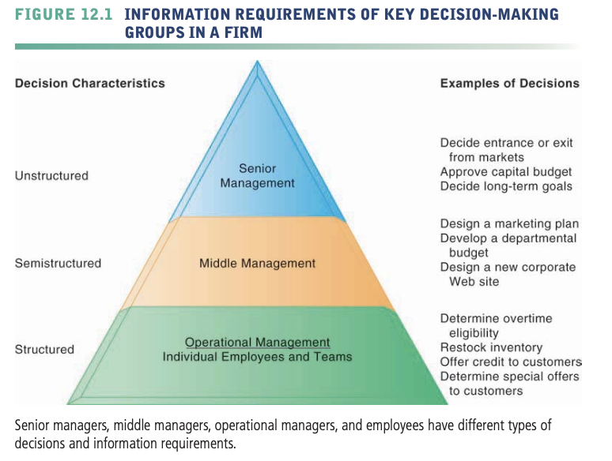

**69 four** different stages in decision making: **intelligence, design, choice,** and **implementation**

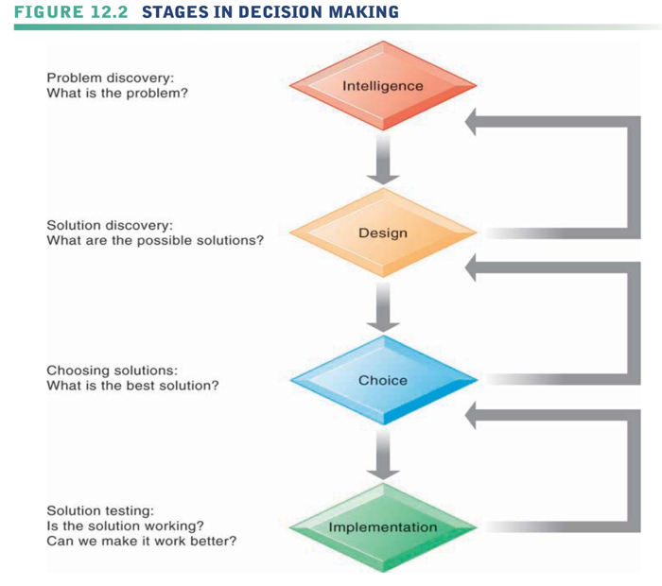

**70 Intelligence** consists of discovering, identifying, and understanding the problems occurring in the organization—why a problem exists, where, and what effects it is having on the firm.

**71 Design** involves identifying and exploring various solutions to the problem.

**72 Choice** consists of choosing among solution alternatives.

**73 Implementation** involves making the chosen alternative work and continuing to monitor how well the solution is working.

**74** The **classical model of management**, which describes what managers do, was largely unquestioned for the more than 70 years since the 1920s.

**75 Behavioral models** state that the actual behavior of managers appears to be less systematic, more informal, less reflective, more reactive, and less well organized than the classical model would have us believe.

**76 Managerial roles** are expectations of the activities that managers should perform in an organization.

**77** Managers act as figureheads for the organization when they represent their companies to the outside world and perform symbolic duties, such as giving out employee awards, in their **interpersonal role**.

**78** In their **informational role**, managers act as the nerve centers of their organizations, receiving the most concrete, up-to-date informa- tion and redistributing it to those who need to be aware of it. Managers are there- fore information disseminators and spokespersons for their organizations.

**79** Managers make decisions. In their **decisional role**, they act as entrepreneurs by initiating new kinds of activities; they handle disturbances arising in the organization; they allocate resources to staff members who need them; and they negotiate conflicts and mediate between conflicting groups.

**80 Three main reasons** why investments in information technology do not always produce positive results:

**Information Quality**. High-quality decisions require high-quality information.

**Management Filters.** Managers have selective attention, and have a variety of biases that reject information that does not conform to their prior conceptions.

**Organizational Inertia and Politics.** strong forces within organizations resist making decisions calling for major change.

**81 Business intelligence**: Infrastructure for collecting, storing, analyzing data produced by business, Databases, data warehouses, data marts

**Business analytics**: Tools and techniques for analyzing data, OLAP, statistics, models, data mining

﻿﻿**Business intelligence vendors**: Create business intelligence and analytics purchased by firms

**82 Six elements** in the **business intelligence environment:**

1. Data from the business environment

2. Business intelligence infrastructure

3. Business analytics toolset

4. Managerial users and methods

5. Delivery platform - MIS, DSS, ESS

6. User interface

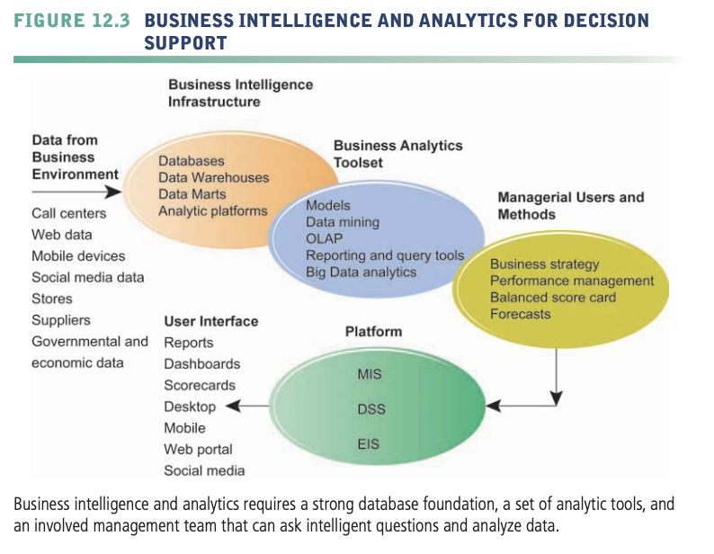

**83 BUSINESS INTELLIGENCE AND ANALYTICS**

**CAPABILITIES**

There are **six analytic functionalities** that BI systems deliver to achieve these ends:

**Production reports**: These are predefined reports based on industry- specific requirements.

**Parameterized reports**: Users enter several parameters as in a pivot table to filter data and isolate impacts of parameters. For instance, you might want to enter region and time of day to understand how sales of a product vary by region and time. If you were Starbucks, you might find that customers in the East buy most of their coffee in the morning, whereas in the Northwest customers buy coffee throughout the day. This finding might lead to different marketing and ad campaigns in each region.

**Dashboards/scorecards**: These are visual tools for presenting performance data defined by users.

**Ad hoc query/search/report creation**: These allow users to create their own reports based on queries and searches.

**Drill down**: This is the ability to move from a high-level summary to a more detailed view.

**Forecasts, scenarios, models**: These include the ability to perform linear forecasting, what-if scenario analysis, and analyze data using standard statistical tools.

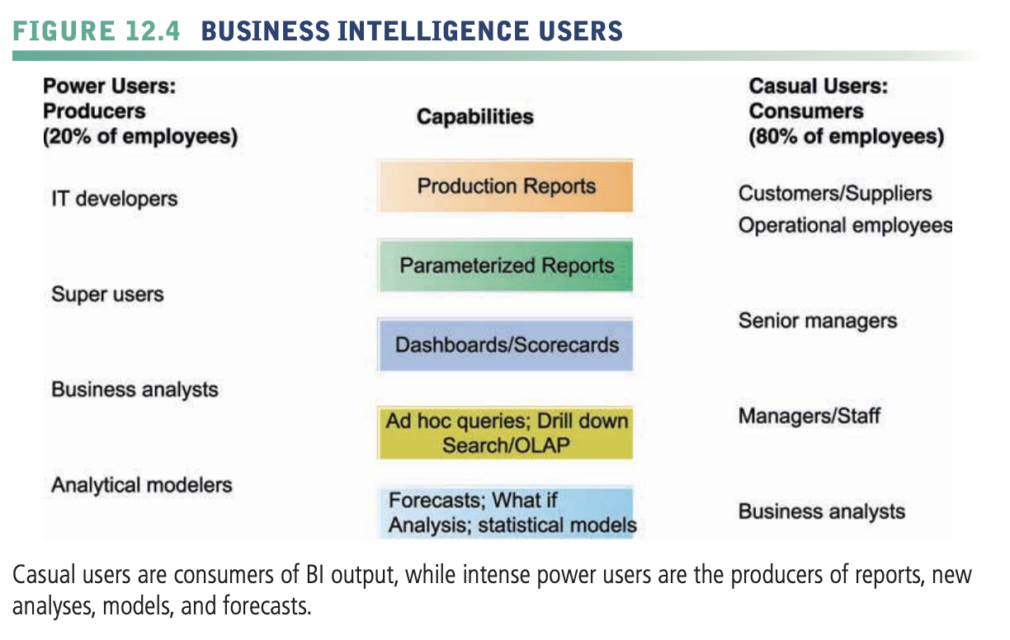

**84 Predictive analytics** use statistical analysis, data mining techniques, historical data, and assumptions about future conditions to predict future trends and behavior patterns.

**85** By presenting data in visual form, **data visualization** and visual analytics tools help users see patterns and relationships in large amounts of data that would be difficult to discern if the data were presented as traditional lists of text or numbers.

**86 Geographic information systems (GIS)** are a special category of tools for helping decision makers visualize problems requiring knowledge about the geo- graphic distribution of people or other resources.

**87 Sensitivity analysis** - models ask what-if questions repeatedly to predict a range of outcomes when one or more variables are changed multiple times.

**88 Pivot table** - manager “super users” and analysts employ to identify and understand patterns in business information that may be useful for semistructured decision making.

**89 Balanced scorecard method** - the leading methodology for understanding the really important information needed by a firm’s executives.

**90 Key performance indicators (KPIs)** - the measures proposed by senior management for understanding how well the firm is performing along any given dimension.

**91 Business performance management (BPM)** - attempts to systematically translate a firm’s strategies (e.g., differentiation, low-cost producer, market share growth, and scope of operation) into operational targets.

**92 Group decision-support systems (GDSS)** - is an interactive computer-based system for facilitating the solution of unstructured problems by a set of decision makers working together as a group in the same location or in different locations.